This is the helping document to get the idea to execute the ADP assignment.

Prerequisite:

Below mentioned tools and technology has been used for reference:

1. Core Java 1.6
2. Apache Maven 3.0.1
3. IDE – Eclipse Kepler

I have created maven based project in my local environment and execute it successfully. I have also written the JUNIT TESTSUITE to verify project positive and negative scenario. Please find the below details to execute/update in project.

|  |  |  |
| --- | --- | --- |
| **Task** | **Location** | **Comment** |
| Property file | src\main\resources\identifyvehicletype.properties | Project specific property are configured in this file like request and response location |
| Request File | resources\input\vehicles.xml | Input file |
| Generated Output File | resources\output\ | Output file |
| XSD file | resources\xsd\ | XSD file |
| Business logic | Src\main\java\ package | Actual code is reside under given location |
| Junit Test | Src\test\java\ package | Junit Test suite is reside under given location |

Run the ADP assignment:

1. Extract the ZIP folder and configure “identifyvechiletype” project in eclipse
2. Go to project location and build project using MAVEN

Project location: mvn clean install

We can also build the project using IDE eclipse.

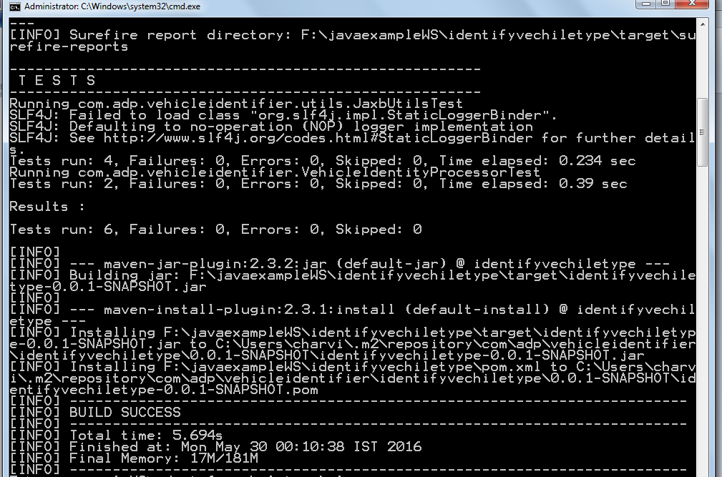

1. I am using the maven JAXB plugin that generates the java files. We have copy the generate java file to src location [I used the maven copy command but it doesnot work for me]

Target file [Copy] - target\generated-sources\jaxb\com\adp\vehicleidentifier\jaxb

Copy those two java files (ObjectFactory.java, Vehicles.java) and paste it to

SRC file [PASTE] - src\main\java\com\adp\vehicleidentifier\jaxb\

1. Refresh the project
2. Execute the main class - VehicleIdentityProcessor.java
3. You can also run test suite - VehicleIdentifyTestSuite.java

Generated Output file:

